DRAWING PAD USING PYTHON
Submitted By
Name: ____________
Roll No: ____________
Branch: ____________

1. Introduction
Drawing Pad is a simple graphical application developed using Python and the Tkinter library. It allows users to draw on a digital canvas using a mouse. The application provides different colours, brush sizes, an eraser, and a clear option. This project helps students understand the basics of GUI programming and event handling in Python.
2. Objective
- To develop a simple drawing application using Python.
- To understand the use of Tkinter for creating graphical user interfaces.
- To learn mouse event handling in Python.
- To improve programming and problem-solving skills.
3. Software Requirements
- Operating System: Windows 10/11
- Programming Language: Python 3.x
- IDE: Visual Studio Code or IDLE
- Library Used: Tkinter
4. Hardware Requirements
- Computer or Laptop
- Minimum 4 GB RAM
- Mouse and Keyboard
5. Modules Used
Tkinter
Used to create the graphical user interface.
tkinter.colorchooser
Used to select custom colours for drawing.
6. Features of the Project
- Draw on the canvas using the mouse.
- Select different colours.
- Adjust brush size.
- Use an eraser.
- Clear the entire drawing area.
7. Algorithm
- Start the program.
- Create the main application window.
- Create a canvas for drawing.
- Add colour buttons and brush size options.
- Detect mouse movements and draw lines.
- Allow the user to erase or clear the drawing.
- End the program when the window is closed.

8. Output
The application opens a drawing window where users can draw freely using different colours and brush sizes.
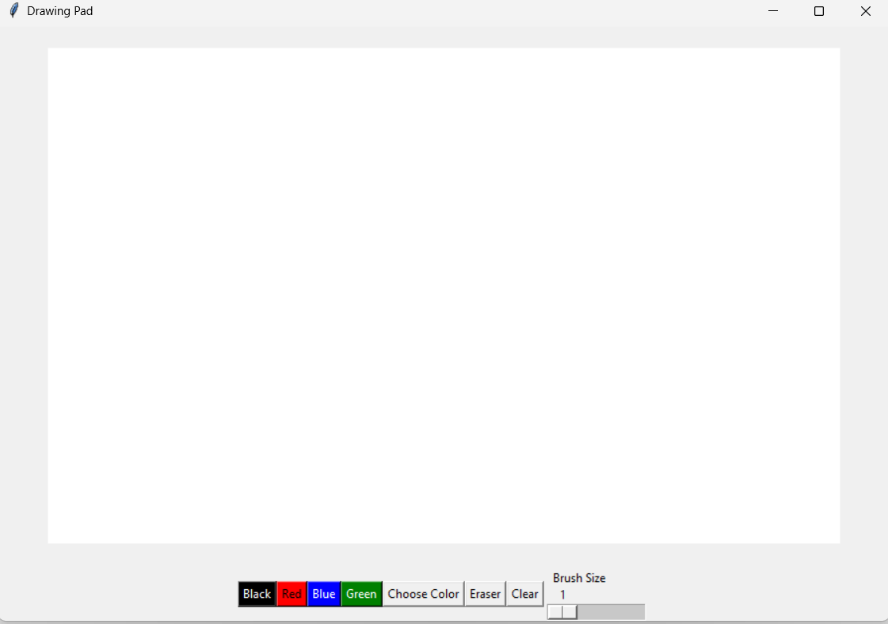
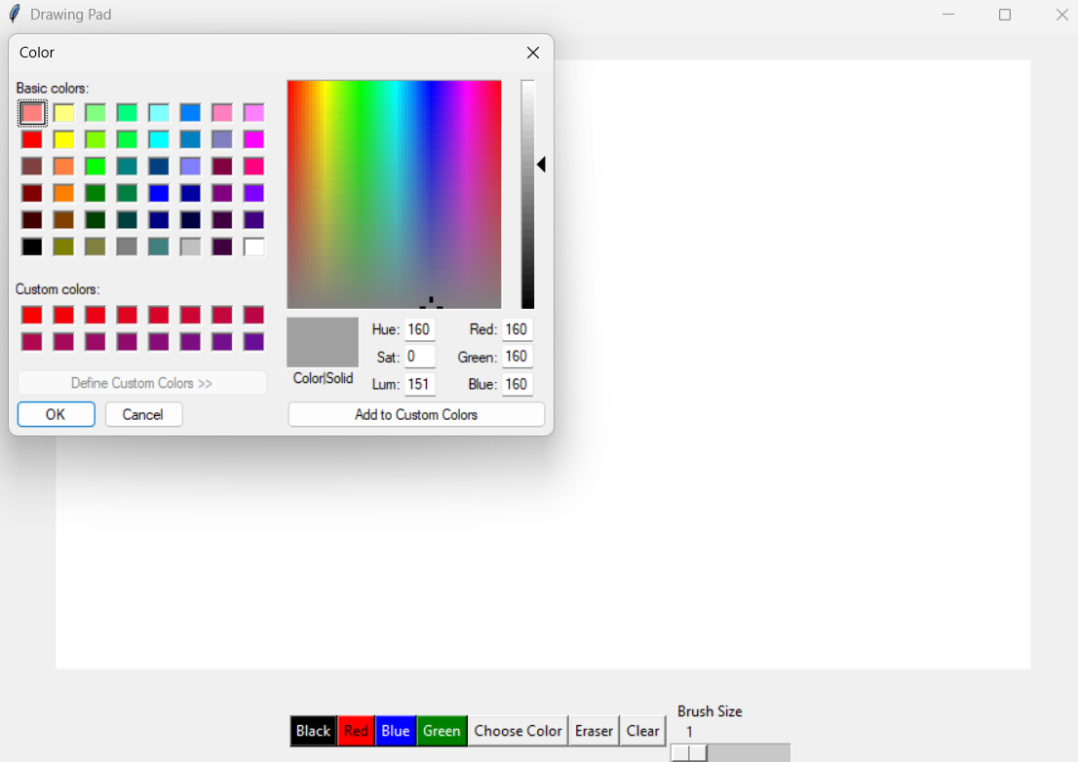
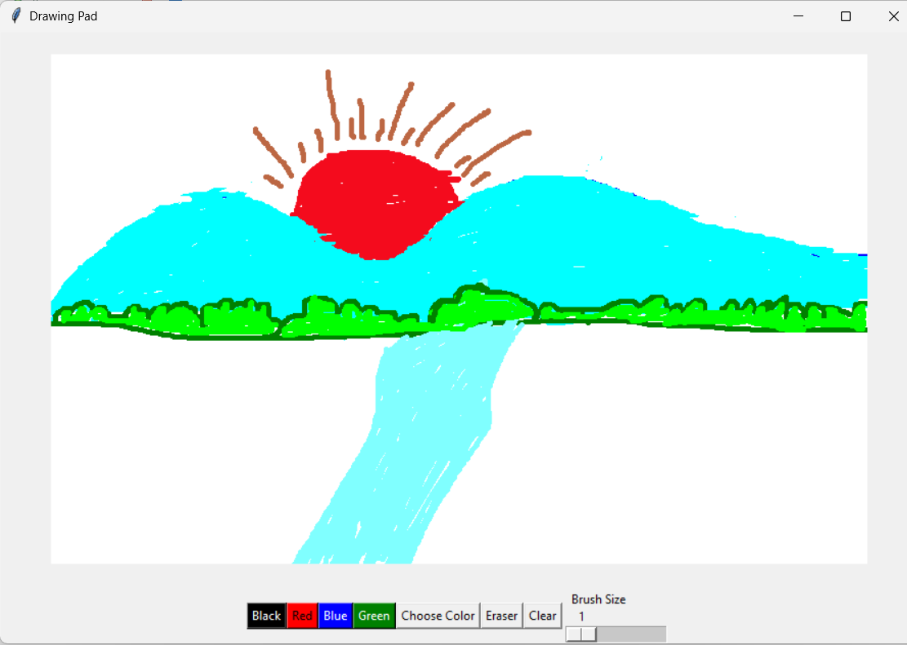
9. Advantages
- Easy to use.
- Interactive and user-friendly.
- Helps in understanding GUI programming.
- Improves creativity.

10. Applications
- Simple digital drawing and sketching.
- Educational purposes.
- Learning Python GUI development.

11. Conclusion
The Drawing Pad project was successfully developed using Python and Tkinter. The project demonstrates the concepts of graphical user interfaces, mouse events, and event-driven programming. It is a simple and useful application for learning Python programming practically.

12. References
- Python Documentation.
- Tkinter Documentation.

